**ER DIAGRAM**

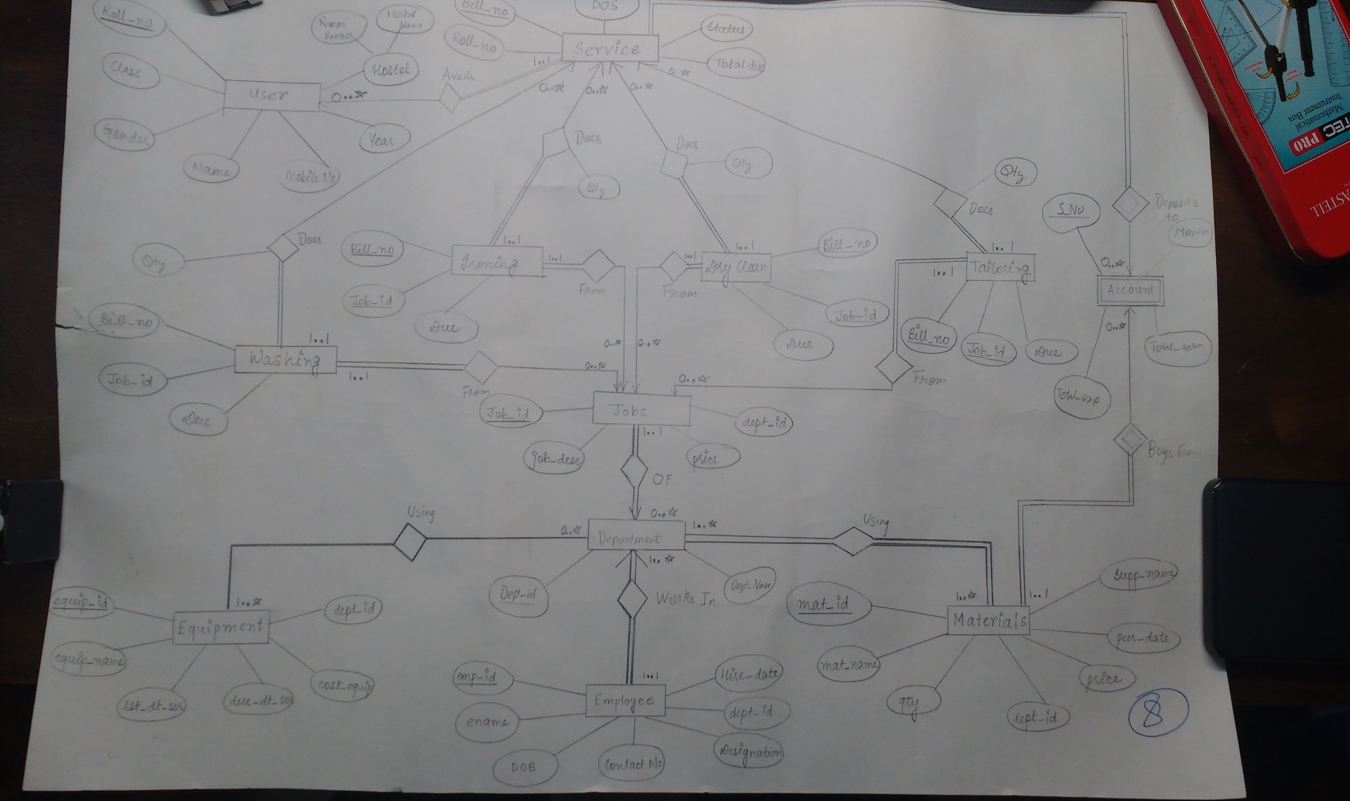

**TABLES**

|  |  |  |
| --- | --- | --- |
| ***Table: user_shop*** | | |
| **Field** | **Datatype** | **Constraint** |
| roll_no | number(10) | Primary key |
| name | varchar(20) | Not Null |
| gender | varchar(2) | check constraint,should either be ‘M’ or ‘F’ |
| class | varchar(3) | check constraint,should either be ‘ME’ or ‘BE’ |
| year | number(2) | Not Null |
| hostel_name | varchar(5) | Not Null |
| room_no | varchar(6) | Not Null |
| mobile_no | number(12) | Not Null |
|  |  |  |
|  |  |  |
|  |  |  |
| ***Table:* services** | | |
| **Field** | **Datatype** | **Constraint** |
| bill_no | number | Primary key |
| roll_no | number(10) | Foreign key,refers user_shop(roll_no) on delete set null |
| dos | date | Not Null |
| status | varchar(5) | should either be ‘NR’ or ‘R’ and default 'NR' |
| total_due | number | Default 0 |
|  |  |  |
|  |  |  |
|  |  |  |
| ***Table:* department** | | |
| **Field** | **Datatype** | **Constraint** |
| dept_id | number(10) | Primary key |
| dept_name | varchar(20) | Not Null |
|  |  |  |
|  |  |  |
|  |  |  |
| ***Table:* jobs** | | |
| **Field** | **Datatype** | **Constraint** |
| job_id | number(10) | Primary key |
| job_desc | varchar(20) | Not Null |
| price | number(10) | Not Null |
| dept_id | number(10) | Foreign key,references department(dept_id) |
|  |  |  |
|  |  |  |
|  |  |  |
| ***Table:* washing** | | |
| **Field** | **Datatype** | **Constraint** |
| bill_no | number(10) | Foreign key,references services(bill_no) |
| job_id | number(10) | Foreign key,references jobs(job_id) |
| qty_id | number | Not Null |
| due | number | default 0 |
| primary key(bill_no,job_id)) | | |
|  |  |  |
|  |  |  |
| ***Table:* ironing** | | |
| **Field** | **Datatype** | **Constraint** |
| bill_no | number(10) | Foreign key,references services(bill_no) |
| job_id | number(10) | Foreign key,references jobs(job_id) |
| qty_id | number | Not Null |
| due | number | default 0 |
| primary key(bill_no,job_id) | | |
|  |  |  |
|  |  |  |
| ***Table:* dry_clean** | | |
| **Field** | **Datatype** | **Constraint** |
| bill_no | number(10) | Foreign key,references services(bill_no) |
| job_id | number(10) | Foreign key,references jobs(job_id) |
| qty_id | number | Not Null |
| due | number | default 0 |
| primary key(bill_no,job_id) | | |
|  |  |  |
|  |  |  |
| ***Table:* tailoring** | | |
| **Field** | **Datatype** | **Constraint** |
| bill_no | number(10) | Foreign key,references services(bill_no) |
| job_id | number(10) | Foreign key,references jobs(job_id) |
| qty_id | number | Not Null |
| due | number | default 0 |
| primary key(bill_no,job_id)) | | |
|  |  |  |
|  |  |  |
|  |  |  |
| ***Table:* employees** | | |
| **Field** | **Datatype** | **Constraint** |
| emp_id | number | Primary key |
| ename | varchar(20) | Not Null |
| dob | date | Not Null |
| hire_date | date | Not Null |
| designation | varchar(20) | Default 'Worker' |
| dept_id | number | Foreign key,references department(dept_id) |
|  |  |  |
| ***Table:* materials** | | |
| **Field** | **Datatype** | **Constraint** |
| mat_id | number | Primary key |
| mat_nam | varchar(20) | Not Null |
| qty | number | Not Null |
| price | number | Default 0 |
| supp_nam | varchar(30) | Not Null |
| dept_id | number | Foreign key,references department(dept_id) |
| pur_date | date | Not Null |
|  |  |  |
|  |  |  |
|  |  |  |
|  |  |  |
| ***Table:* equipment** | | |
| **Field** | **Datatype** | **Constraint** |
| equip_id | number | Primary key |
| equip_name | varchar(20) | Not Null |
| ls_dt_ser | date | Not Null |
| due_dt_ser | date |  |
| cost_equip | number | Default 0 |
|  |  |  |
|  |  |  |
|  |  |  |
| ***Table:* accounts** | | |
| **Field** | **Datatype** | **Constraint** |
| sno | number | Primary key |
| month | varchar(10) | Not Null |
| tot_exp | number | default 0 |
| tot_earn | number | default 0 |
| net_earn | number | default 0 |

**FD DIAGRAMS**

***Table name: user_shop***

name

Mobile_no

Roll_no

hostel

Room_no

year

gender

class

***Table name: services***

Roll_no

dos

Bill_no

status

Total-due

***Table name: department***

Dept_name

Dept_id

***Table name: jobs***

Price

Job_id

Dept_id

Job_desc

***Table name: employees***

ename

dob

Emp_id

Hire_date

designation

Dept_id

Contact_no

***Table name: washing***

due

Bill_no

qty

Job_id

***Table name: ironing***

Bill_no

qty

due

Job_id

***Table name: tailoring***

Bill_no

qty

due

Job_id

***Table name: dry_clean***

Bill_no

qty

due

Job_id

***Table name: materials***

Mat_nam

qty

Mat_id

price

Supp_name

Dept_id

Pur_dat

***Table name: equipment***

Equip_name

Dept_id

Equip_id

Cost_equip

Ls_dt_ser

Due_dt_ser

***Table name: accounts***

month

Tot_exp

sno

Tot_earn

net_earn